Integration of Microsoft Azure



Contents

1. Introduction 2

2. Methods of Integration 2

3. Azure as User/Password Identity 2

3.1 Create and configure the Azure Application 2

3.2 Connecting with DoubleClue Enterprise Management (DCEM) 5

3.3 Disabling this feature 5

3.4 Importing Azure Users to DoubleClue 6

4. Configure Azure as a Service Provider Hybrid with Active Directory 7

4.1 Creating a federated Azure Domain 7

4.2 Configuring DoubleClue for Azure 8

4.3 Exporting the DoubleClue metadata 8

4.4 Configuring the Azure Domain Federation with Powershell 8

The code sample in this chapter is meant for administrators who want to federate only one Azure domain with DCEM. If you want to federate several Azure domains with DCEM, please check the further instructions in chapter 4.7 Federating multiple Azure Domains with one DCEM Cluster. 9

4.5 Users in federated Domain 10

4.6 Verify Access to Office online 11

4.7 Federating multiple Azure Domains with one DCEM cluster 11

Abbreviations:

DCEM = DoubleClue Enterprise Management

# Introduction

This documentation describes how to integrate Microsoft Azure with DoubleClue Identity & Access Management (IAM).

# Methods of Integration

There are three different scenarios to integrate Microsoft Azure with DoubleClue:

1. Azure as User/Password Identity-Provider (MFA Policy done be DCEM)
2. Azure as a Service-Provider Hybrid with Active Directory
3. Azure as full Identity-Provider for DoubleClue

# Azure as User/Password Identity

In this scenario, DCEM login procedure will verify the user credentials with Microsoft Azure.

If azure successfully verifies the user credentials, DCEM will automatically import the user into DCEM database if not yet present. User will inherit are DCME privileges form the Azure Groups he is member of.

After Azure verification, DCEM will process the authentication policies and execute the MFA requirements as defined DCEM the policies.

Azure will not demand MFA form users, even if they are configured for MFA. MFA will be done be DCEM

## Create and configure the Azure Application

1. Log into your Global Administrator account on [https://portal.azure.com](https://portal.azure.com/)
2. 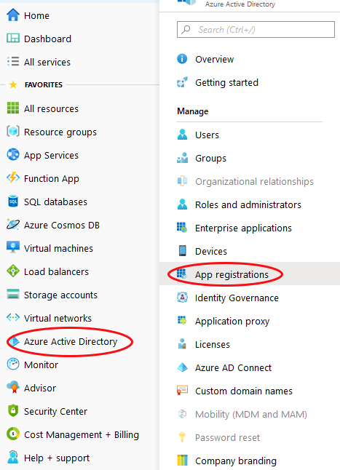Go to “Azure Active Directory” and choose “App Registrations” in the submenu.
3. Click on “New Registration”. If you have already registered an app you wish to use, select it instead and skip directly to step 5.
4. Give your application an easily recognisable name, eg. “DoubleClue”. Then choose the account type you want to support and click “Register”.
5. Copy the “Application (client) ID” and “Directory (tenant) ID” from the application side. Store them in a safe location – you will need them later.
6. 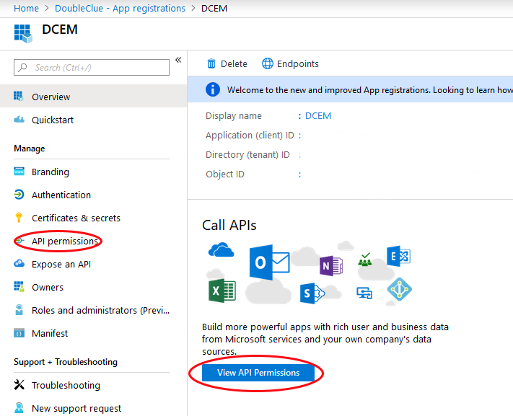Click on “View API Permissions” or “API Permissions” from the submenu on the left side of the app registration page.
7. Choose “Add a permission” and select “Microsoft Graph” then “Application permissions”. This will open the menu to select permissions.
8. Open the menu item “Directory” and enable “Directory.Read.All”. Then open the item “Users” and enable “User.Read.All”. Confirm the selection with the “Add Permission”-Button at the bottom of the menu.
9. Choose “Add a permission” again and select “Microsoft Graph” then “Delegated permissions”. Open the item “Users” and enable “User.Read.All”. Confirm the selection with the “Add Permission”-Button at the bottom of the menu.
10. Make sure to grant Admin consent to all permissions.
11. Go to “Certificates & Secrets” in the submenu on the left.
12. Add a “New Client Secret” and choose an expiration time.
13. Copy the value of the client secret. Be aware that the secret is only shown once! Should it be lost, it can’t be restored and a new secret has to be defined.

## Connecting with DoubleClue Enterprise Management (DCEM)

1. Log into DCEM as an administrator.
2. Go to “Administration” in the main menu and then to “Domain” in the sub menu.
3. Add a new Domain.
4. Choose “Azure Active-Directory” as Domain-Type.
5. Graphical user interface, text, application, email

   Description automatically generated
6. Select a meaningful and easily memorable name, like the company name. Note that this name will be the prefix users will need to add to their User ID to identify themselves with DoubleClue.
7. Paste the Tenant ID and Client ID from the value you copied in step 3.1.5 in the respective fields.
8. Paste in the Client Secret from the value you copied in step 3.1.12 in the respective field.
9. In “Map E-Mail Siffixes to this Domain” enter the domain. For example if user is ‘name.surname@doubleclue.onmicrosoft.com’ then enter ‘doubleclue.onmicrosoft.com’
10. Confirm the input. You now have a successfully connected your DCEM to the Azure app.

## Disabling this feature

This feature can be disabled by enabling the checkbox ‘Use Only Azure Direct Login’ in the Administration->Preferences. Default is off.

## Importing Azure Users to DoubleClue

Administrator may import users form azure to DCEM. But this isn’t necessarily at all. As users are automatically imported in DCEM if they are successful login in with user credentials.

# Configure Azure as a Service Provider Hybrid with Active Directory

In this scenario DCEM will verify the user credentials with on premisses Active-Directory and applies its MFA policies.

DoubleClue will also applies its MFA policies for all other Azure Apps like Outlook, Teams, Office 365 etc.. For this you have to add a federated Domain for Azure.

With federated Domain, Azure acts as a SAML Service-Provider and DoubleClue as the SAML Identity-Provider. 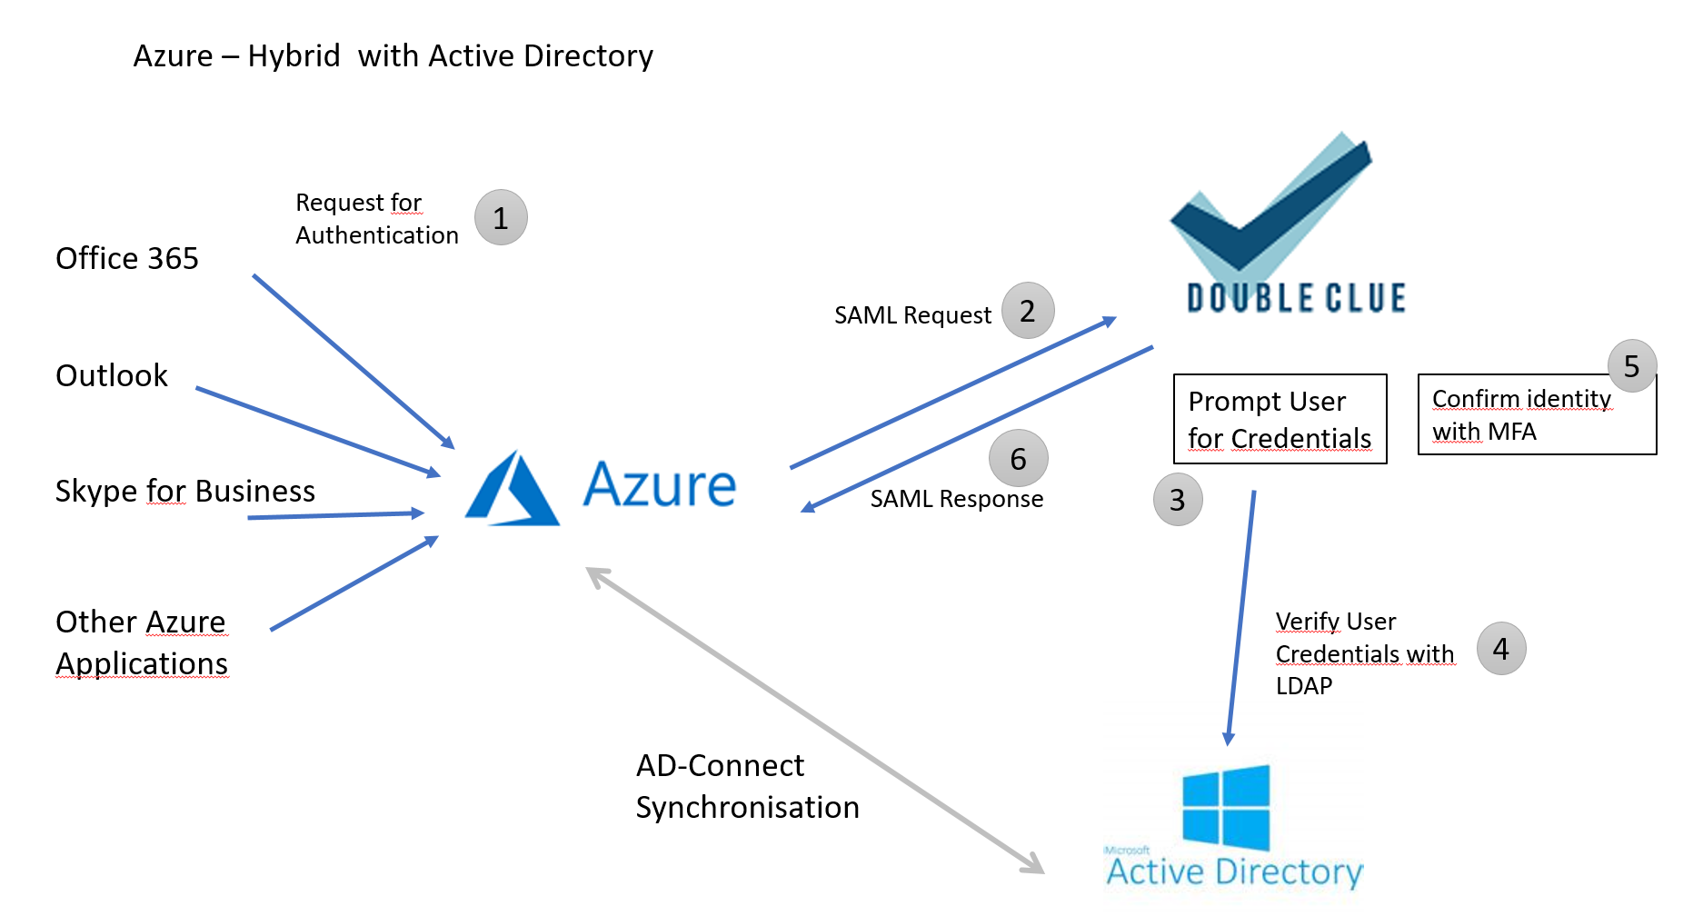

The federation uses the SAML protocol for the communication between Azure and DoubleClue. Both parties have first to trust each other by exchanging the SAML metadata before establishing the federation.

## Creating a federated Azure Domain

* The primary domain “tenant.onmicrosoft.com” cannot be configured for federation. You first need to create a new domain.
* The domain must be configured to Azure AD-Connect Sync with the on premises Active Directory.
* Once a domain is federated, the users have to be synchronized with Active Directory or other Identity Providers. You cannot add users or reset user passwords once the domain has been federated.

## Configuring DoubleClue for Azure

DoubleClue comes with a preconfigured Azure metadata. To use it, follow the steps below:

1. Log into DCEM
2. In the main menu, navigate to “SAML” and open the sub menu “Service Providers”
3. Add a new Service Provider and select SP Configuration “Microsoft Azure”
4. Confirm and save the new service provider

## Exporting the DoubleClue metadata

Azure does not support the SAML standard metadata format. To establish a federation, you therefore require the following data from DoubleClue:

* + Logon URL
  + Entity ID
  + Certificate

**Logon-URL**  
The host name of the Logon-URL is configured in DCEM. In the main menu, navigate to “SAML” and here to “Preferences”. The host URL is defined in the field “SSO Domain” field, for example: [*https://example-url.example-company.com*](https://example-url.example-company.com). The Login URL is composed of the “SSO Domain” and the suffix “dcem/saml”. In our example, the login URL would be[***https://example-url.example-company.com/dcem/saml***](https://example-url.example-company.com/dcem/saml)*.*

**Entity ID**  
Each SAML entity (service providers and identity providers) possess an Entity ID. It is a globally unique identifier exchanged during the software configuration to federate DCEM with Microsoft Azure domains. The entity ID can be defined in DCEM under SAML -> Preferences. You can choose it freely as long as it is unique.

**Certificate**  
You can download the certificate in DCEM under “SAML” -> “Service Providers”. Click on “Download Idp Metadata” and choose “Download Certificate”.

## Configuring the Azure Domain Federation with Powershell

The Azure Domain federation is configured with Power Shell commands. To use the Windows PowerShell cmdlets, you must first download the [Azure Active Directory Modules](https://docs.microsoft.com/powershell/azure/install-adv2?view=azureadps-2.0).

## C:\Users\maike.behnsen\Desktop\Grafiken\caution-sign.pngThe code sample in this chapter is meant for administrators who want to federate only one Azure domain with DCEM. If you want to federate several Azure domains with DCEM, please check the further instructions in chapter 4.7 Federating multiple Azure Domains with one DCEM Cluster.

1. Connect to your Azure AD Directory as a tenant administrator with:   
   ***Connect-MsolService***
2. Now use **Set-MsolDomainAuthentication** to federate the azure Domain. Use the following sample with the data you exported from DoubleClue as described in chapter 4.3:

$dom = " yourazure.domain.com "  
$BrandName = "DoubleClue SAML 2.0 IDP"  
$LogOnUrl = “[***https://example-url.example-company.com/dcem/saml***](https://example-url.example-company.com/dcem/saml)***”***$LogOffUrl = “[***https://example-url.example-company.com/dcem/saml***](https://example-url.example-company.com/dcem/saml)***”***  
$EntityId = "*example-url.example-company.de*"  
$MySigningCert = "  
"

Set-MsolDomainAuthentication`  
-DomainName $dom `  
-FederationBrandName $dom`  
-Authentication Federated `

-IssuerUri $EntityId `  
-PassiveLogOnUri $LogOnUrl `  
-LogOffUri $LogOffUrl  
-SigningCertificate $MySigningCert `  
-PreferredAuthenticationProtocol “Samlp”

**DomainName** specifies the fully qualified domain name (FQDN)

**FederationBrandName** specifies the name of the string value shown to users when signing in to Azure Active Directory services. We recommend that customers use something that is familiar to them, like their company name

**$MysigningCert** is the certificate you downloaded from “Exporting the DoubleClue metadata”

**$LogOnUrl, $LogOffUrl** is the host URL, which is defined in the field “SSO Domain” with the suffix “dcem/saml”.

**$EntityId** is defined in DCEM under SAML -> Preferences. In case you want to federate multiple Domains, see (4.7).

**Authentication** specifies the authentication type of the domain (Federated)

**Samlp** is the authentication protocol

1. To check the configuration, you can execute   
   Get-MsolDomainFederationSettings ***-domainname “***mydomain.com”***|*** format***-***list ***\****

Microsoft references:

<https://docs.microsoft.com/en-us/azure/active-directory/hybrid/how-to-connect-fed-saml-idp#configuring-a-domain-in-your-azure-ad-directory-for-federation>

<https://docs.microsoft.com/en-us/previous-versions/azure/dn194112(v=azure.100)?redirectedfrom=MSDN>

**Note**

If you converted a domain, rather than adding one, it may take up to 24 hours to set up single sign-on. **Before you verify single sign-on, you should finish setting up Active Directory synchronization, synchronize your directories and activate your synced users**.

## Users in federated Domain

Users in federated domain can be created by Azure Ad connect. For more detailed information, see [Integrate your on-premises directories with Azure Active Directory](https://docs.microsoft.com/en-us/azure/active-directory/hybrid/whatis-hybrid-identity).

Windows PowerShell can also be used to automatically add new users to Azure AD and to synchronize changes from the on-premises directory.

**Note**

The New-MsolUser cmdlet can be used to create a new user in Microsoft Azure Active Directory. In order for this to have access to services, it must have a license (via the parameter"LicenseAssignment").

The following procedure shows how to add a single user to Azure AD.

1. Connect to your Azure AD Directory as a tenant administrator: *Connect-MsolService*.
2. Create a new user principal:

PowerShellCopy

New-MsolUser

-UserPrincipalName john.smith@example.com

-ImmutableId ABCDEFG1234567890  
 -DisplayName "John Smith"

-FirstName “John”

-LastName “Smith “

-AlternateEmailAddresses "john.smith@something.com"

-LicenseAssignment "samlp2test:ENTERPRISEPACK"

-UsageLocation "DE"

For more information about “New-MsolUser”, see <https://technet.microsoft.com/library/dn194096.aspx>

## Verify Access to Office online

You can now log into office.com using DoubleClue as your Identity Provider.

1. Open your browser and enter <https://office.com>
2. As user name, enter the user principal name like   
   [name.surname@your-domain-name](mailto:name.surname@your-domain-name)
3. As your domain is federated, Azure will redirect you to the DoubleClue login page.
4. After a successful DoubleClue authentication, you will be automatically redirected to Office.com as a login user.

## Federating multiple Azure Domains with one DCEM cluster

It is possible to federate several Azure Domains with one DCEM cluster. To establish such a federation, you need to follow the following instructions during the configuration of both – DCEM and Azure.

Per default, every Service Provider in DoubleClue needs a unique Entity ID and every Identity Provider in Azure needs a unique Entity ID. This information is defined in the metadata. To federate several azure domains with one DCEM, do the following:

**In Azure:**

When formulating the Entity ID for your DCEM in Azure, ensure that you compose it according to the following formula – the DCEM entity and the domain name from your UPN separated by a slash:

the DCEM entity ID (as defined in the SAML preferences) + / + the domain name from the UPN.

Example:

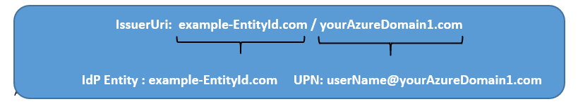

**In DCEM:**

All Azure Domains use the same Entity ID. It is therefore not possible, to add Azure as a Service Provider several times. However, one Azure Entry will recognize several domains if you check the **‘Add User Domain to IdP Entity’** under IdP Settings.

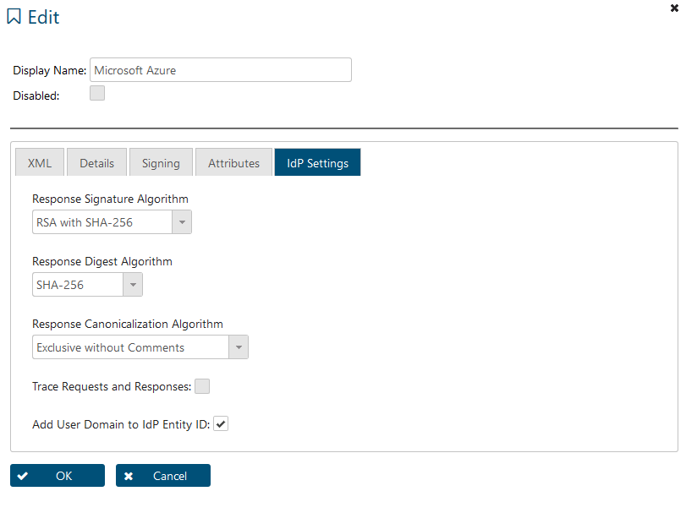

If the box is checked, DCEM will add the domain name to the Entity ID which is defined in preferences and will send the IdP Entity ID as **EntityID/DomainName** in SAML responses**.** It is thereby recognized as the unique Entity ID by Azure. If a SAML request is send from Azure to DCEM, the Entity ID will be automatically divided into the Entity ID as defined in the preferences and the domain name by DCEM.

**Adjusted Powershell Code:**

Below you will find samples to configure two Azure domains for one DCEM.

$dom = " yourAzureDomain1.com "  
$BrandName = "DoubleClue SAML 2.0 IDP"  
$LogOnUrl = “[***https://example-url.example-company.com/dcem/saml***](https://example-url.example-company.com/dcem/saml)***”***$LogOffUrl = “[***https://example-url.example-company.com/dcem/saml***](https://example-url.example-company.com/dcem/saml)***”***  
$EntityId = "example-EntityID.de/yourAzureDomain1.com"  
$MySigningCert = "  
"

Set-MsolDomainAuthentication`  
-DomainName $dom `  
-FederationBrandName $dom`  
-Authentication Federated `

-IssuerUri $EntityId `  
-PassiveLogOnUri $LogOnUrl `  
-LogOffUri $LogOffUrl  
-SigningCertificate $MySigningCert `  
-PreferredAuthenticationProtocol “Samlp”

# Azure as full Identity-Provider for DoubleClue

In this scenario Azure will do full user authentication including Azure policies and MFA.

This feature must be enabled by enabling the checkbox ‘Enable Azure Direct Login’ in the administration->Preferences. Default is off.

Users will click on “Login with Microsoft Azure” or enters the DCEM-URL for azure. The browser will be redirected to azure login procedure. When azure login procedure is done, Azure will direct the user to the DCEM Welcome page and use is successful login in DCEM.

## Addition Configuration for the Azure App

Add Azure Domain in DCEM as described in ” 3.1 Create and configure the Azure Application” and “3.2 Connecting with DoubleClue Enterprise Management (DCEM)”

You need to add the DCEM URLs to the Azure-DoubleClue -App as follows:

1. Go to Portal.azure.com
2. Proceed to ‘App registrations’
3. Select the DoubleClue App
4. Go to ‘Authentication’
5. Click on ‘Web’
6. And add your DCEM URLS
7. Save

The Dcem Urls for DoubleClue.online are:

* ‘yourTenantName.doubleclue.online/dcem/mgt’ For management
* ‘yourTenantName.doubleclue.online/dcem/userportal’ for the user Portal